4.2.7 Packet Tracer - Configure Router-on-a-Stick Inter-VLAN Routing
Addressing Table
Device | Interface | IPv4 Address | Subnet Mask | Default Gateway
R1 | G0/0.10 | 172.17.10.1 | 255.255.255.0 | N/A
 | G0/0.30 | 172.17.30.1 | 255.255.255.0 | N/A
PC1 | NIC | 172.17.10.10 | 255.255.255.0 | 172.17.10.1
PC3 | NIC | 172.17.30.10 | 255.255.255.0 | 172.17.30.1

Objectives
- Part 1: Add VLANs to a Switch
- Part 2: Configure Subinterfaces
- Part 3: Test Connectivity with Inter-VLAN Routing

Scenario
In this activity, you will configure VLANs and inter-VLAN routing. You will then enable trunk interfaces and verify connectivity between VLANs.

Instructions

Part 1: Add VLANs to a Switch

Step 1: Create VLANs on S1.
Create VLAN 10 and VLAN 30 on S1.

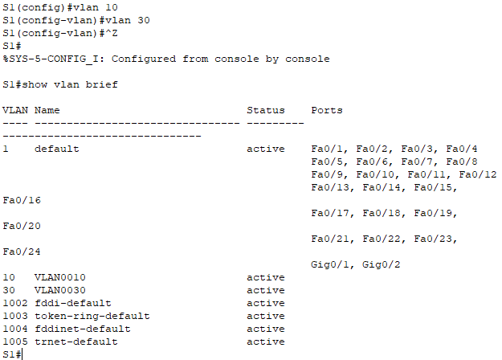
S1#enable
S1#configure terminal
S1(config)#vlan 10
S1(config-vlan)#vlan 30

Step 2: Assign VLANs to ports.
- Configure interfaces F0/6 and F0/11 as access ports and assign VLANs.
- Assign the port connected to PC1 to VLAN 10.
- Assign the port connected to PC3 to VLAN 30.
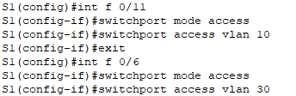
S1(config)#int f 0/11
S1(config-if)#switchport mode access
S1(config-if)#switchport access vlan 10
S1(config-if)#exit
S1(config)#int f 0/6
S1(config-if)#switchport mode access
S1(config-if)#switchport access vlan 30

- Issue the show vlan brief command to verify VLAN configuration.
S1# show vlan brief

VLAN Name Status Ports
---- -------------------------------- --------- -------------------------------
1 default active Fa0/1, Fa0/2, Fa0/3, Fa0/4
Fa0/5, Fa0/7, Fa0/8, Fa0/9
Fa0/10, Fa0/12, Fa0/13, Fa0/14
Fa0/15, Fa0/16, Fa0/17, Fa0/18
Fa0/19, Fa0/20, Fa0/21, Fa0/22
Fa0/23, Fa0/24, Gig0/1, Gig0/2
10 VLAN0010 active Fa0/11
30 VLAN0030 active Fa0/6
1002 fddi-default active
1003 token-ring-default active
1004 fddinet-default active
1005 trnet-default active

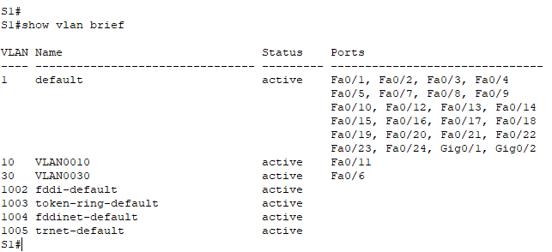
S1#show vlan brief

Step 3: Test connectivity between PC1 and PC3.
From PC1, ping PC3
Were the pings successful? Why did you get this result?
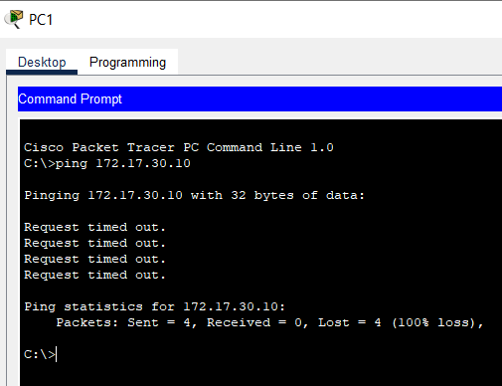
The ping fails because PC1 is in VLAN 10 and PC3 is in VLAN 30. With different VLANs, the two PCs cannot ping and communicate with each other.

Part 2: Configure Subinterfaces

Step 1: Configure subinterfaces on R1 using the 802.1Q encapsulation.
- Create the subinterface G0/0.10.
- Set the encapsulation type to 802.1Q and assign VLAN 10 to the subinterface.
- Refer to the Address Table and assign the correct IP address to the subinterface.
R1(config)#int g0/0.10
R1(config-subif)#encapsulation dot1Q 10
R1(config-subif)#ip address 172.17.10.1 255.255.255.0

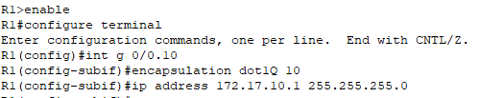
R1>enable
R1#configure terminal
R1(config)#int g 0/0.10
R1(config-subif)#encapsulation dot1Q 10
R1(config-subif)#ip address 172.17.10.1 255.255.255.0

- Repeat for the G0/0.30 subinterface.

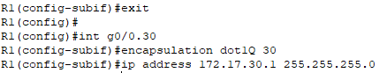
R1(config)#int g0/0.30
R1(config-subif)#encapsulation dot1Q 30
R1(config-subif)#ip address 172.17.30.1 255.255.255.0

Step 2: Verify Configuration.
- Use the show ip interface brief command to verify subinterface configuration. Both subinterfaces are down. Subinterfaces are virtual interfaces that are associated with a physical interface. Therefore, in order to enable subinterfaces, you must enable the physical interface that they are associated with.
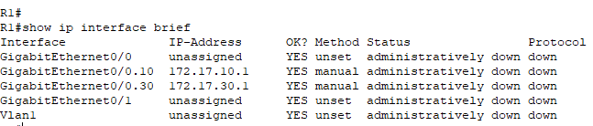
Administratively down

- Enable the G0/0 interface. Verify that the subinterfaces are now active.
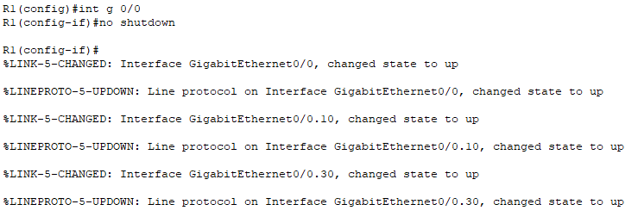
R1(config)#int g 0/0
R1(config-if)#no shutdown
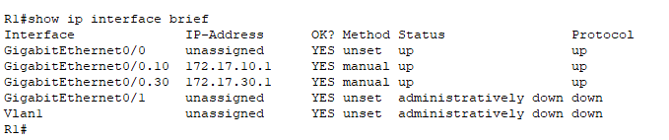

Part 3: Test Connectivity with Inter-VLAN Routing

Step 1: Ping between PC1 and PC3.
From PC1, ping PC3. The pings should still fail. Explain.
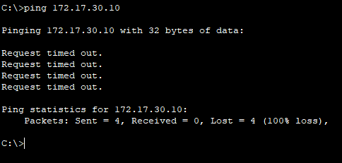
Because the switch has not been configured with trunk ports(enable trucking), the interface g 0/1 should allow VLAN 10 as well as VLAN 30 so that PC1 and PC3 can communicate with each other.

Step 2: Enable trunking.
- On S1, issue the show vlan command.
What VLAN is G0/1 assigned to?
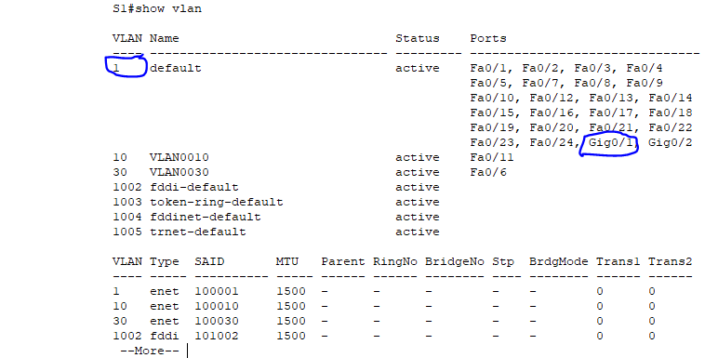
VLAN 1

- Because the router was configured with multiple subinterfaces assigned to different VLANs, the switch port connecting to the router must be configured as a trunk. Enable trunking on interface G0/1.
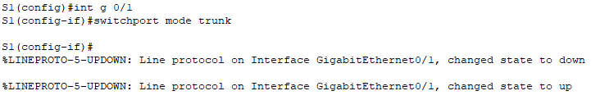
S1(config)#int g 0/1
S1(config-if)#switchport mode trunk

How can you determine that the interface is a trunk port using the show vlan command?
No, we cannot use the show vlan command to verify, we have to give a show interface trunk command.

- Issue the show interface trunk command to verify that the interface is configured as a trunk.
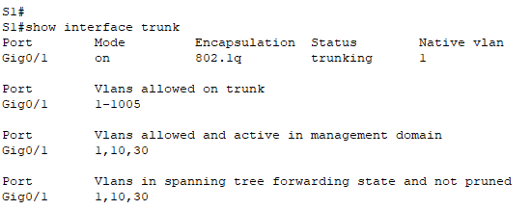
S1#show interface trunk

Step 3: Test Connectivity
If the configurations are correct, PC1 and PC3 should be able to ping their default gateways and each other.
What addresses do PC1 and PC3 use as their default gateway addresses?
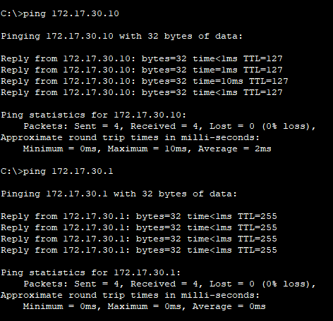
PC1 will use its default gateway as the ip address for the subinterface G 0/0.10 interface.
PC3 will use its default gateway as the ip address for the subinterface G 0/0.30 interface.
They use the subinterface's address.

